Title: Protecting Data with Point-in-Time Recovery (PITR) in AWS DynamoDB

Introduction:

Data protection is a critical aspect of any application or system. Amazon Web Services (AWS) offers Point-in-Time Recovery (PITR) as a powerful feature in DynamoDB, allowing you to restore your data to any desired point in time. In this blog post, we will explore the steps involved in configuring and using PITR for backup and restore in AWS DynamoDB. Let's dive in!

Step 1: Access the DynamoDB Console :

Log in to the AWS Management Console and navigate to the DynamoDB service. This is where you can manage your DynamoDB tables.suppose we create a student_info DynamoDB table and create some items.

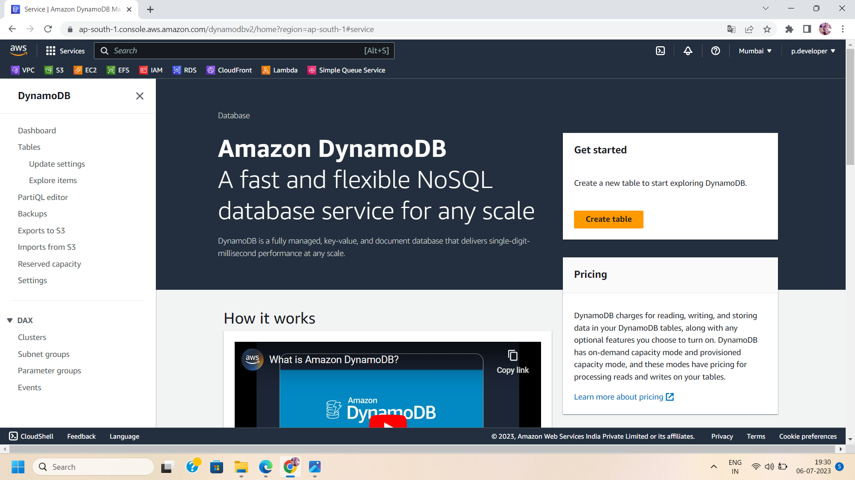

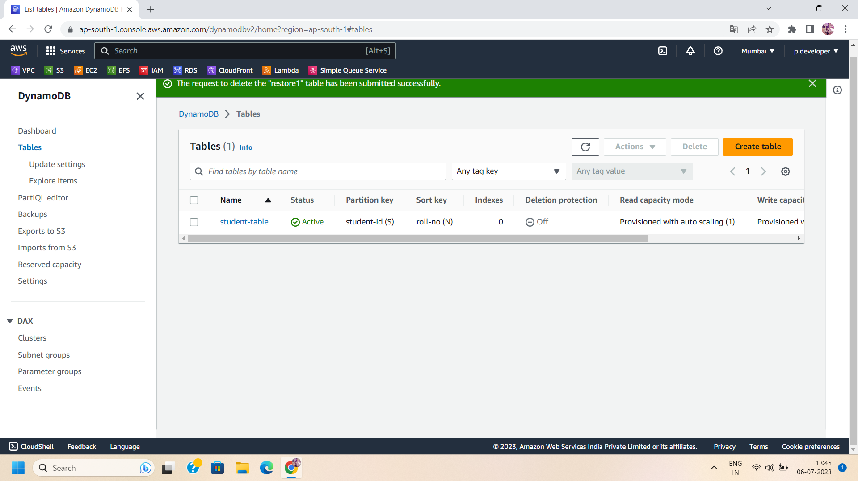

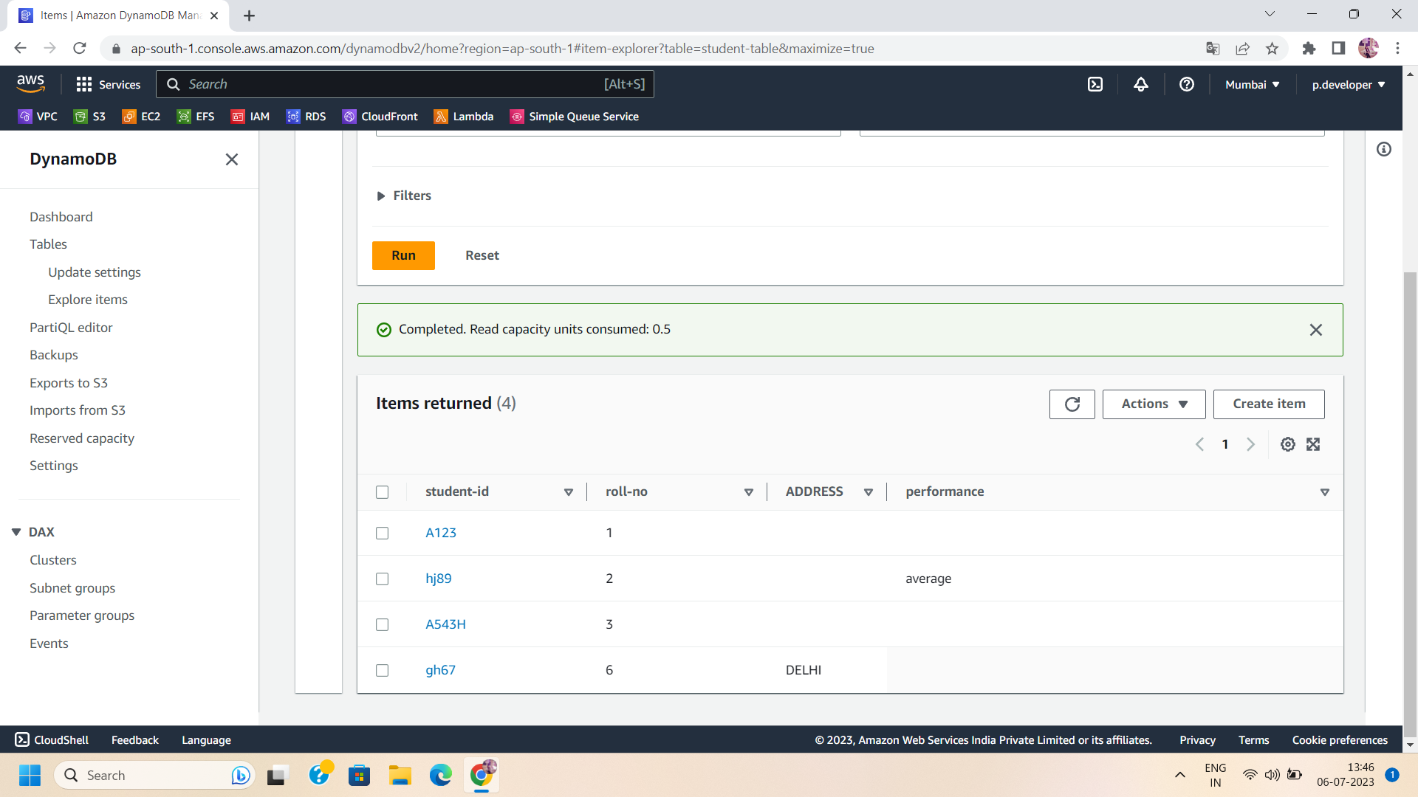

NOTE: To create a dynamoDB table from scratch ,checkout this link:

—----------------------------------------------------

Step 2: To enable PITR for a table, select the table for which you want to enable PITR. In the table overview, go to the "Overview" tab and click on the "Backup" button. This will open the PITR settings for the selected table.

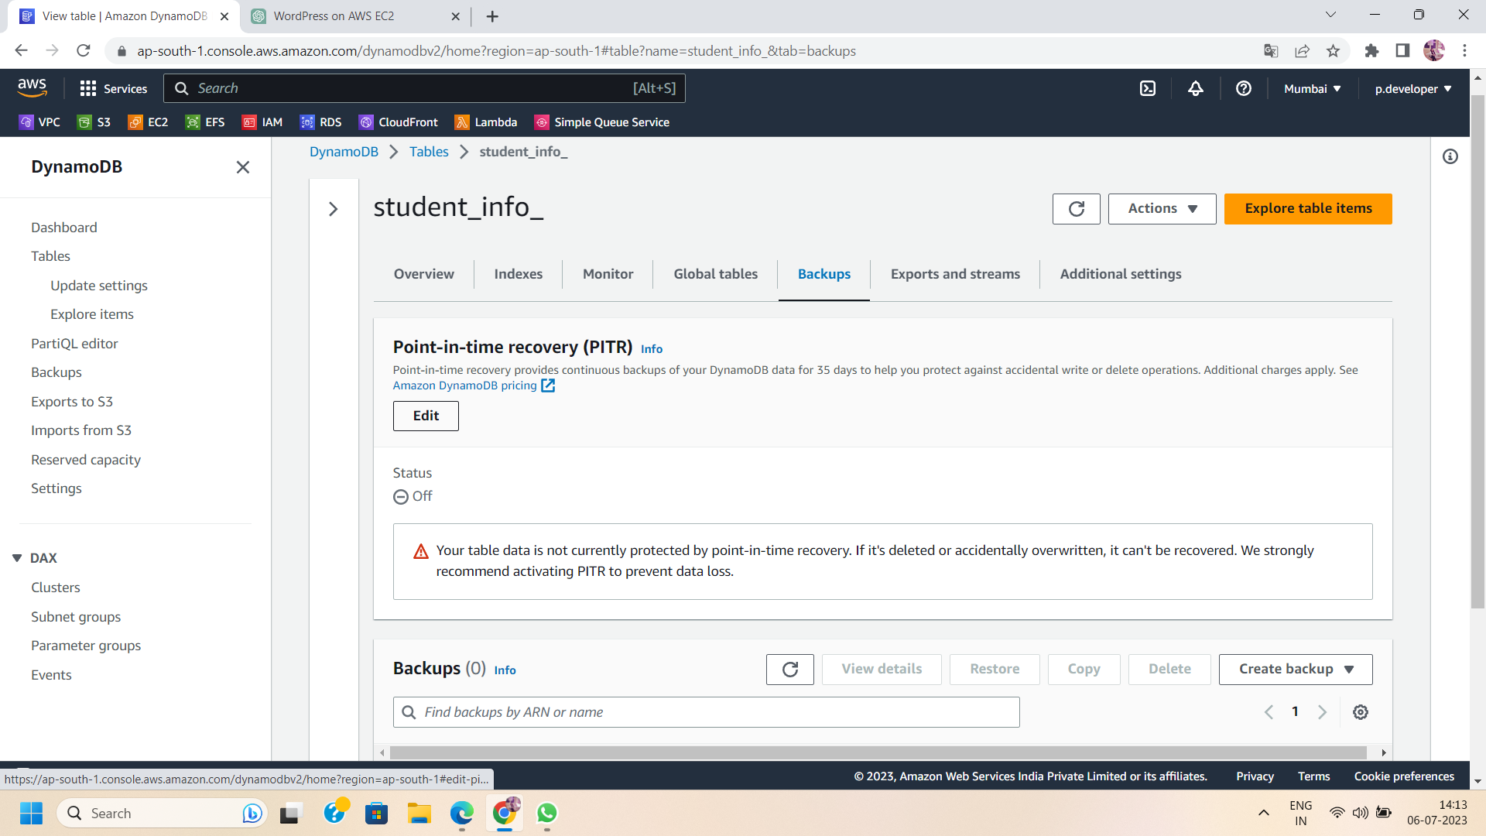

Step 3: Enable PITR In the PITR settings, click on the "Enable PITR" button. Enabling PITR will create automatic backups of your DynamoDB table and allow you to restore the data to any point in time within the specified retention period.

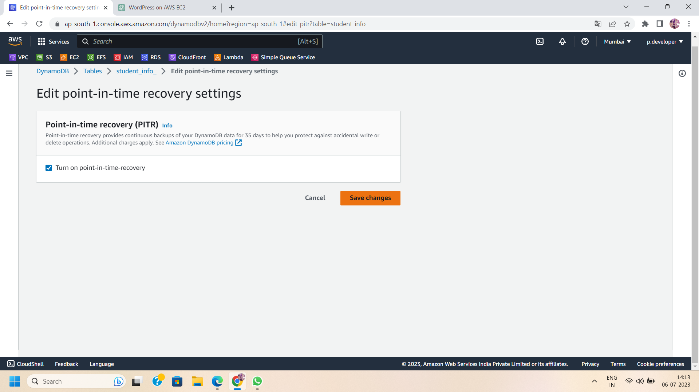

Step 4: Monitor Backup Status:

Once PITR is enabled, DynamoDB will automatically create and manage backups for your table. You can monitor the backup status in the "Overview" tab of the table's settings. DynamoDB will display the latest backup timestamp and other relevant information.

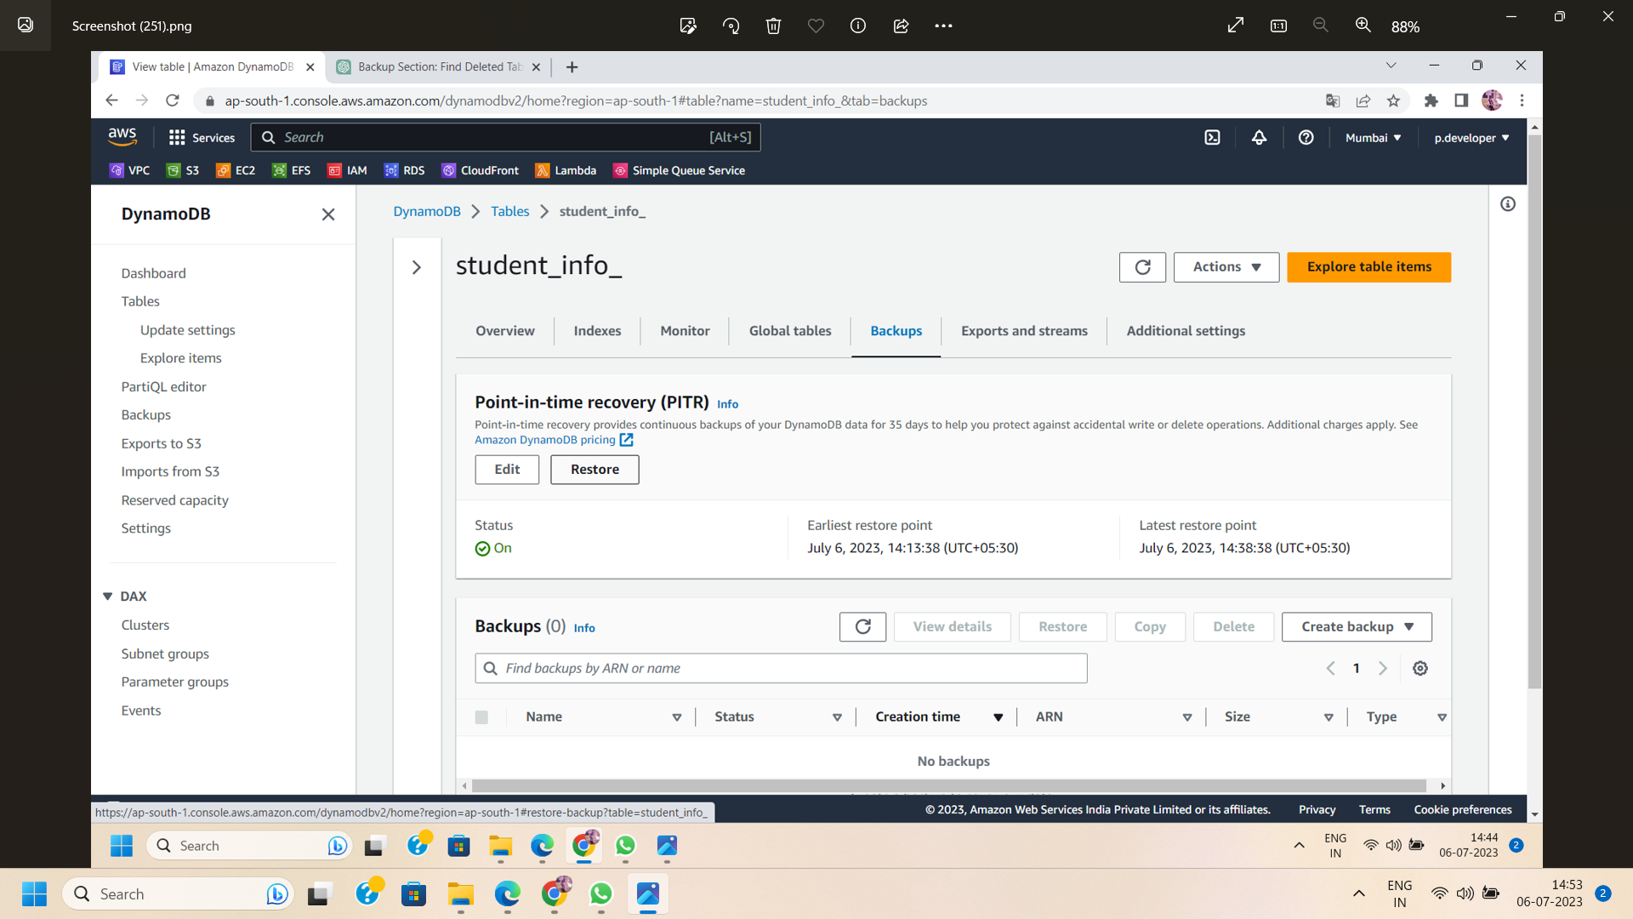

Step 5: Once you enable the PITR , delete the table .

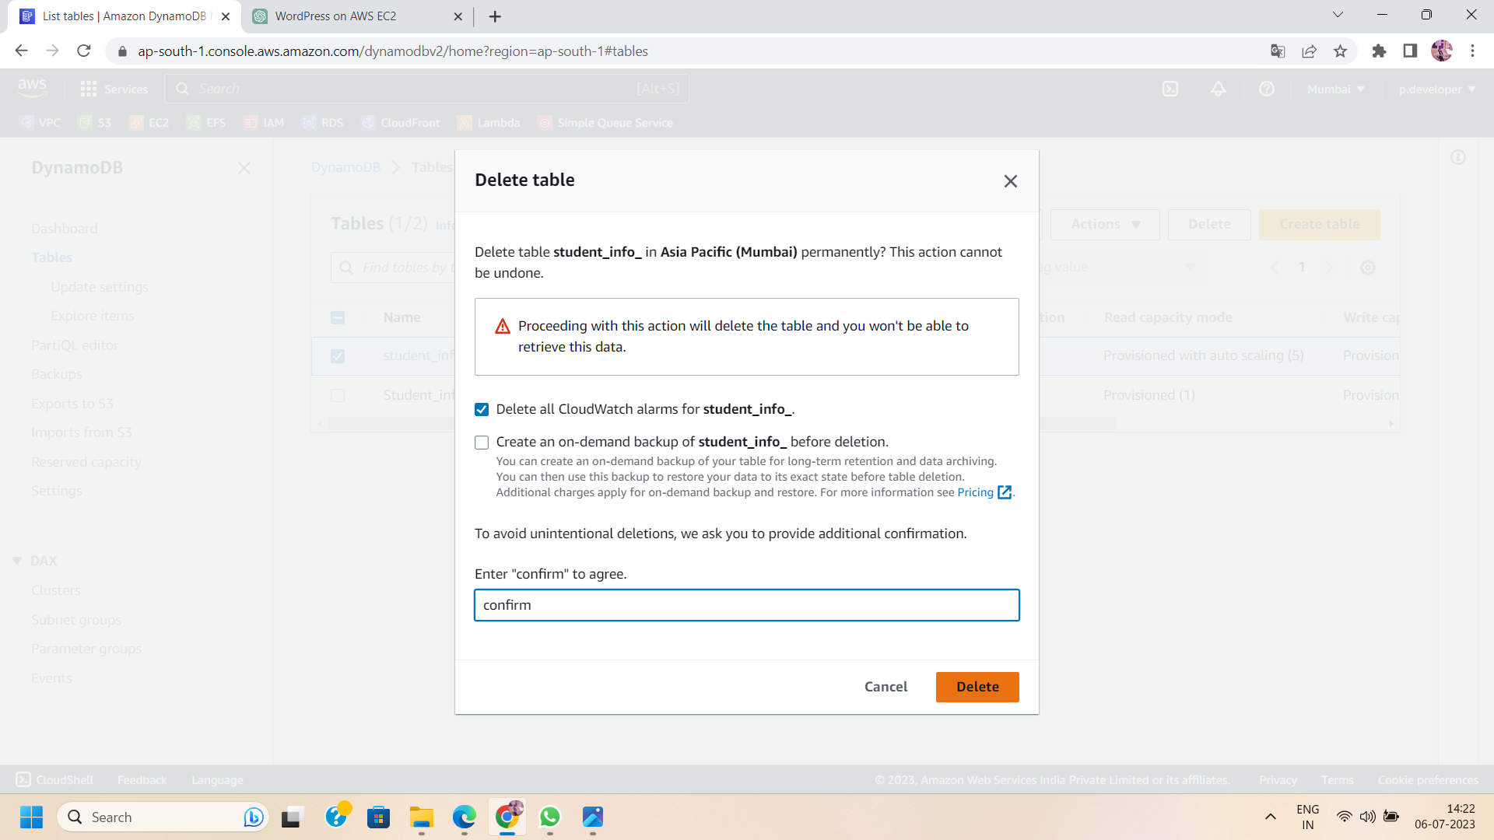

Step 6: Now,visit the backup section. Here you will find a backup file of the deleted table.As DynamoDB automatically creates a backup of the table in the backup section.

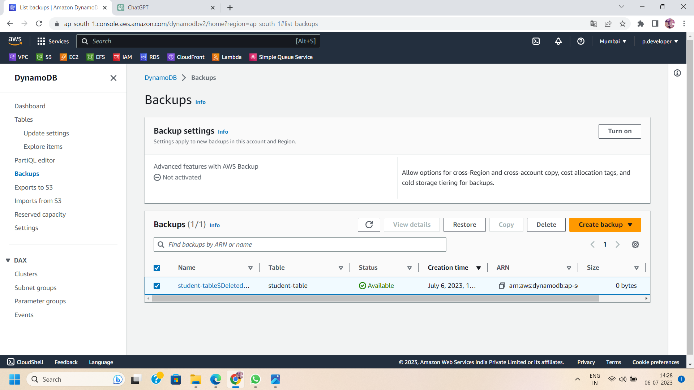

Step 7: Restore the backup file:

In case you accidentally delete the file or need to restore it in the future, PITR provides a retention period of 35 days. Within this period, you can restore your table. To initiate the restoration process, choose the backup file and select the "restore" option.

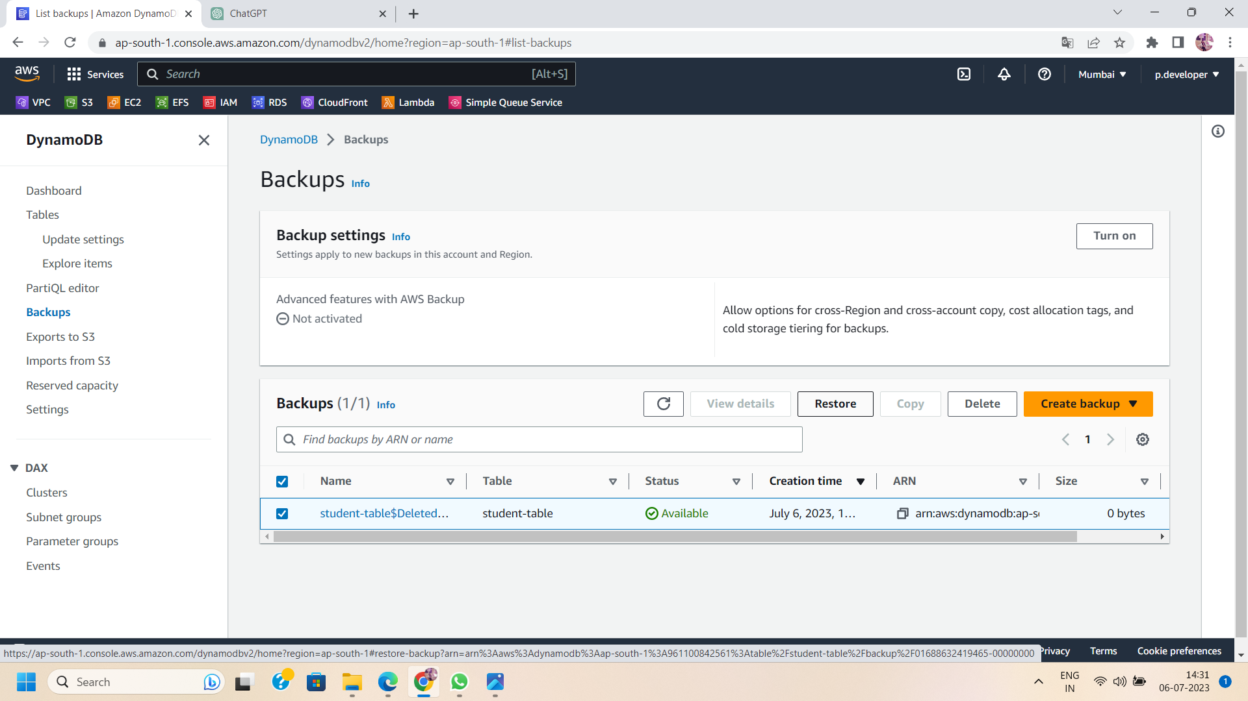

Step 8: Create Restore file:

Configure the Restoration During the restoration process, you can configure various settings, such as the table name, destination and encryption setting. Review and adjust these settings according to your requirements.

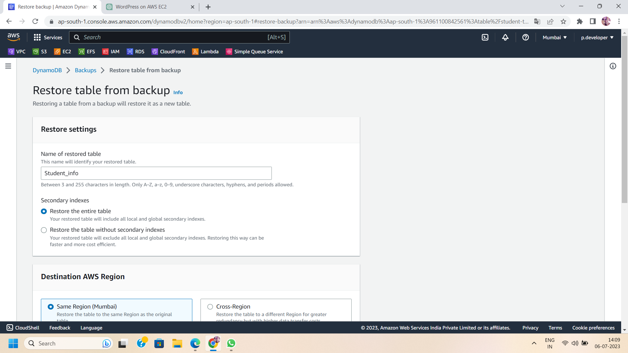

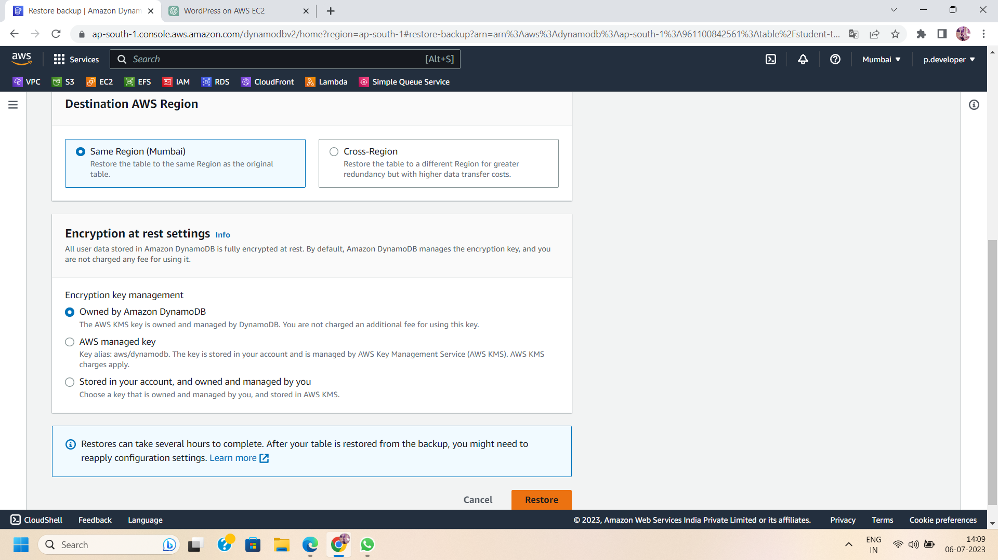

Step 9: Move to the table dashboard :

After creating the restore file ,move to the table dashboard. Here you will find your restored file.It will take time to change the status from restoring to active.

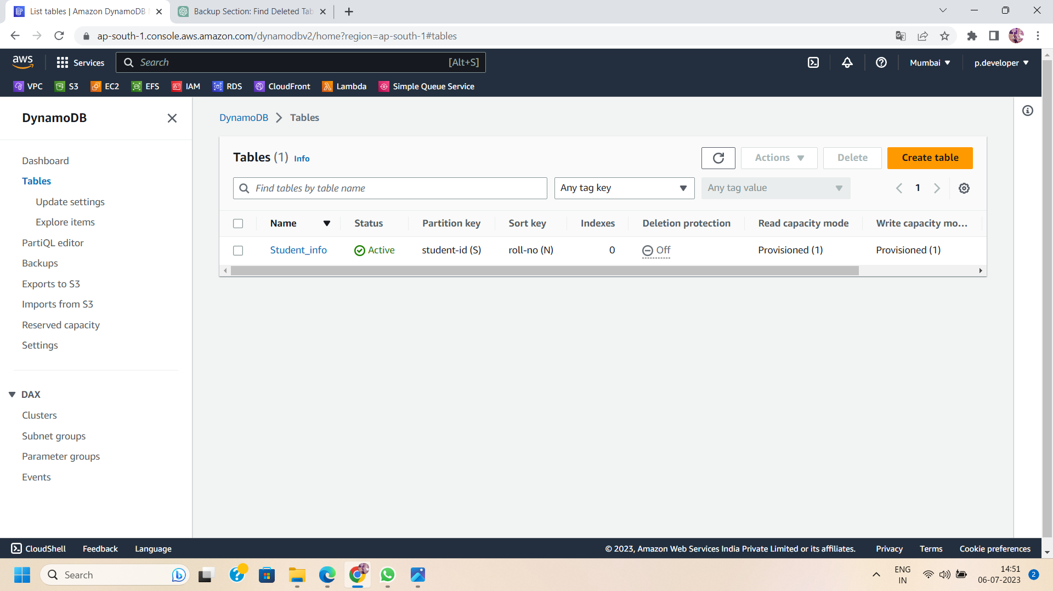

Step 10: Test and Validate the Restored Data:

Once the restoration is complete, validate the restored data by performing tests and verifying its integrity. This step ensures that the restored data is accurate and reflects the desired point in time.

Conclusion:

By leveraging Point-in-Time Recovery (PITR) in AWS DynamoDB, you can protect your data and have the flexibility to restore it to any desired point in time. The process of enabling PITR, monitoring backups, and restoring data provides a robust data protection mechanism for your DynamoDB tables. Implement PITR in your applications and gain confidence in the recoverability of your data. Safeguard your critical information with AWS DynamoDB's PITR feature and ensure uninterrupted business operations.